Focus on Resilience
We all hit ‘bumps in the road’ in our professional lives but how well can we deal with them will vary. Resilience is about adapting and coping skills, understanding and managing emotional responses and seeking support to ensure ability to ‘bounce back’ and learn from or grow after a stressful event. Why not consider looking at this short video to learn more, and feel free to share it with colleagues and trainees.
Click here for more information:
Resilience

Performance Support Unit Launched and Open for Business

In February of this year the new NHS Education Scotland Performance Support Unit for medical trainees was launched. As of end of May we have been referred x trainees thought to be in need of level 3 support.
Details of what the new PSU does and who and how to refer trainees can be found at Performance Support Unit
As this website is new we would welcome comments from anyone about how it can be improved. Please contact Abi White

Performance News
Performance Support Unit

Title
Sub-title

Meet the Staff
We are delighted that Dr Craig Urquhart and Mr. Brian Singer have been appointed as case managers working with the Performance Support Team.
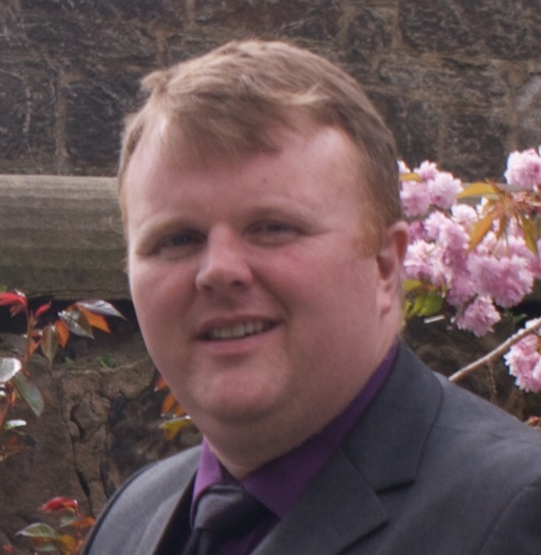
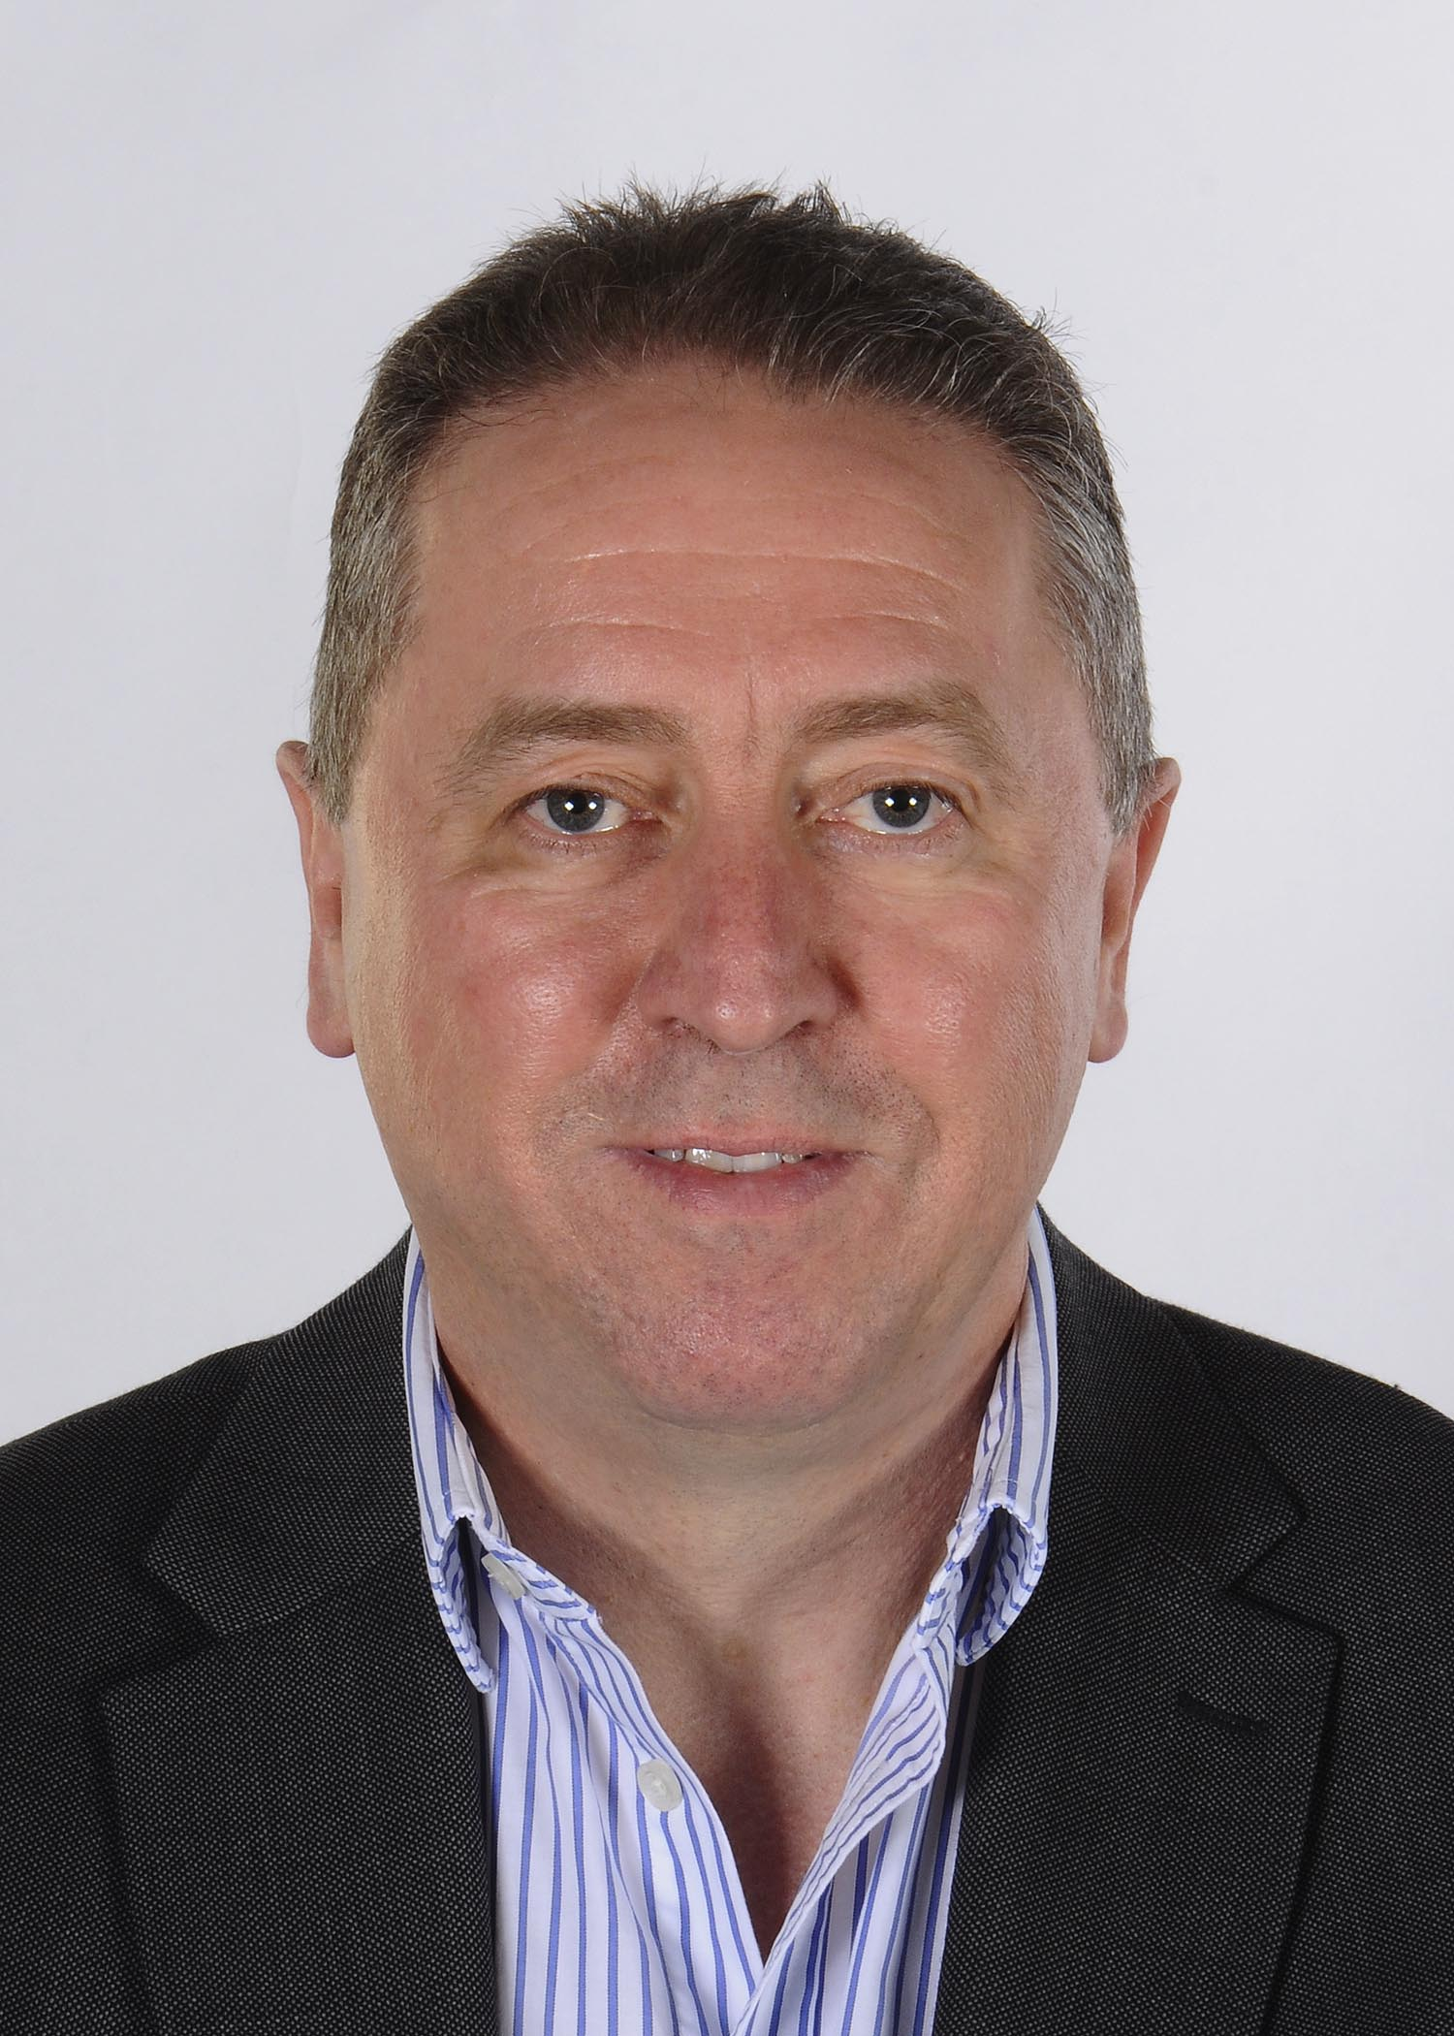
Craig Urquhart is a Case Manager in the NHS Education for Scotland Performance Support Unit. He works as an
Anaesthetic Consultant in the QEUH, Glasgow. He is one of the RCoA College Tutors within the QEUH and is an
Honorary Clinical Senior Lecturer for the University of Glasgow. He is involved in the organisation and
delivery many anaesthetic workshops and meetings. In March 2017, he received an Excellence in
Training Award by the RCoA.

Brian Singer is a Case Manager in the NHS Education for Scotland Performance Support Unit. He is also Foundation Program Director in East Region and previous education roles include Training Programme Director for Trauma & Orthopaedic Surgery. He works as a Consultant in Trauma & Orthopaedic Surgery in Perth.

